**Preliminary Research**

**Existing Solutions:**

* Cornell
  + 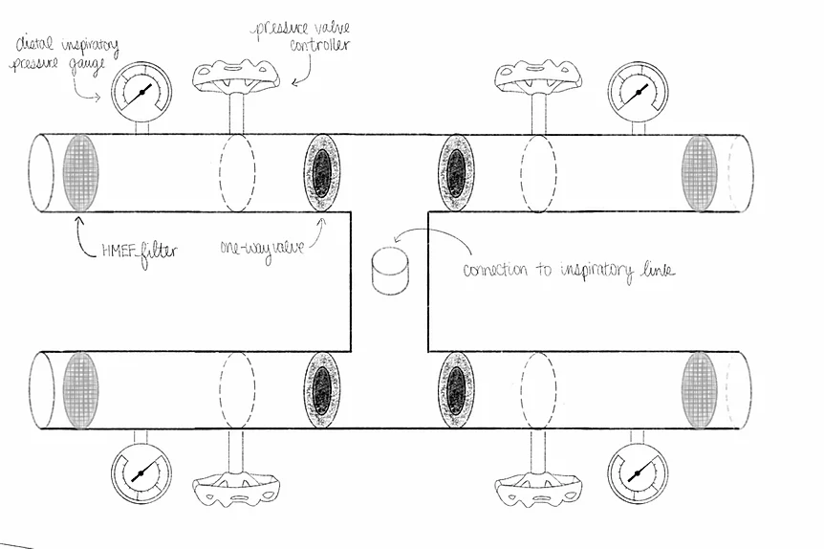
  + 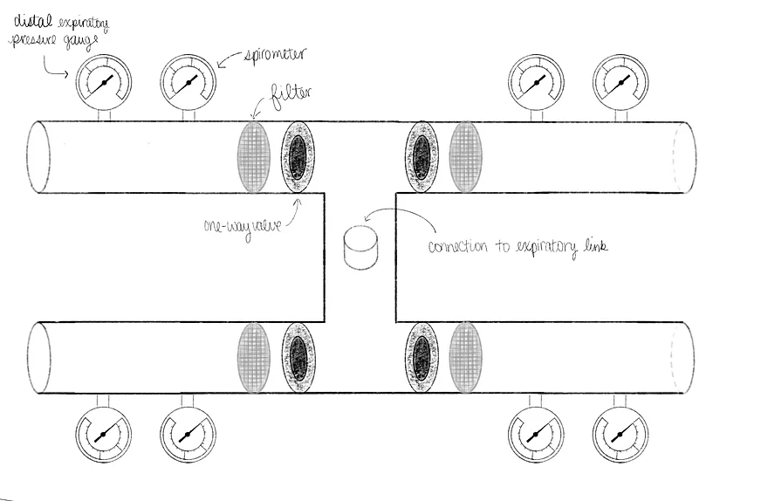
* Johns Hopkins - 3D printed solution - if it’s approved by the FDA the solution will be open source

**Problem Statement:** Patients can’t share ventilators because each individual might need different ventilator settings. The shortage occurring currently of ventilators means there’s a huge need for finding a way to be able to split ventilators between multiple patients.

“A ventilator is designed and can be set for only one patient at a time. Since two patients are unlikely to require oxygen at the same amount and pressure, one might get too little oxygen while the other receives too much, injuring their lungs either way. Also, the air tubes might distribute contaminants between patients. Reflecting these concerns, one major ventilator manufacturer and the American Association for Respiratory Care both discourage hospitals from connecting machines to multiple patients. Some hospitals are reluctant to try it under any circumstances and are looking for other backup plans.”

**The Biggest Issues:**

1. Being able to provide oxygen at the correct volume or pressure for individual patients (mechanical method to change volume or pressure??)
2. Prevent contamination in air tubes!

Once we start splitting a ventilator between multiple patients, Using a volume-cycled mode has numerous, major disadvantages:

1. Using a volume-cycled mode with multiple patients provides *no* control over the tidal volume of any patient, and also provides *no* control on the maximal airway pressure. This is literally the worst of both worlds.
2. A volume-cycle mode will introduce the possibility of deleterious interactions between patients. For example, let’s suppose Patient A’s endotracheal tube gets kinked. This will cause Patient B to receive dangerously large tidal volumes!
3. Patients sharing the ventilator must have similar *size*, similar FiO2 and similar PEEP requirements. *HOWEVER, most covid patients have high PEEP reqs*

**How we will Improve Existing Solutions + New Ideas:**

* Improve upon the crude nature of the Cornell Design (manual pressure gauges/spirometers) - is there a way to make this more seamlessly integrated?
* Some sort of software to plug into a ventilator that seamlessly provides specific pressure/volume to different tubes? May require more power
* \*\***3d design/print a y-tube** to split ventilator (can also do a t-tube if we want to share ventilator between more than one) + **have an end tidal monitor for CO2** (since they will be using pressure settings not volume, so they need a way to monitor efficacy of ventilation- **can incorporate into the valve for exhale**) + **1 way valves** to prevent backflow, use FIXED DRIVING PRESSURE** + **a filter**
* We may even be able to add a spirometer to assist with tidal volume measurements, and some sort of **alert system** if any of these things are changed so doctors don’t have to constantly be monitoring this
* The CO2 monitor can be used to also alert doctors for hypercapnia or hypocapnia (pH of blood/gas)
  + single sensor and rotate it between patients in case of a shortage (?)

**Rough Sketch of the Idea**

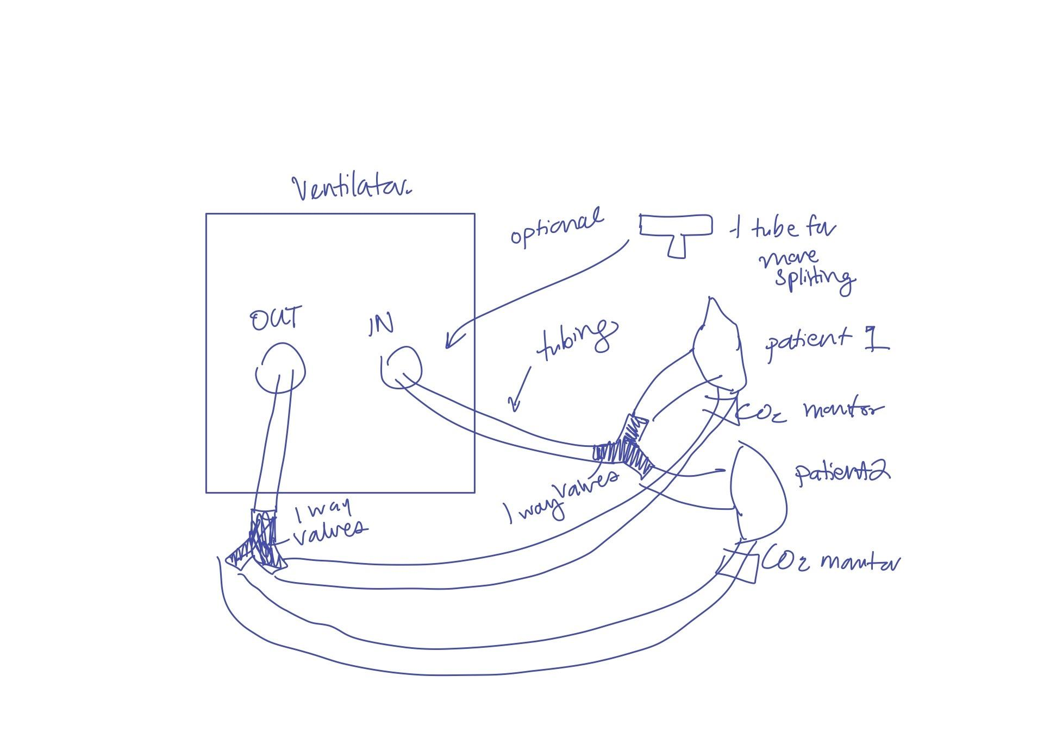

What we still need to know:

* Pressure driving ranges (what would be considered a low driving pressure and a high PEEP)
* How would we test this to ensure it is properly ventilating each patient to the necessary tidal volumes
* Even with the CO2 monitor, how can we provide feedback to alter pressure etc to ensure the correct ventilation?
  + Use a microcontroller (e.g. Arduino) that receives CO2 level output and sends signal to increase/decrease pressure
* Materials access
* Not sure if we could find a way to rotate sensor between two patients without risking contamination
  + Could we avoid contamination depending on the placement? I.e. the air that touched the sensor would not have the chance to be directed to the patient (assuming there’s no backflow)

**Useful Resources:**

* Ventilator Sharing Protocol- this is how they do it normally: <https://www.gnyha.org/wp-content/uploads/2020/03/Ventilator-Sharing-Protocol-Dual-Patient-Ventilation-with-a-Single-Mechanical-Ventilator-for-Use-during-Critical-Ventilator-Shortages.pdf>
* Some information on Johns Hopkins Solution: <https://www.medicaldesignandoutsourcing.com/how-3d-printing-is-enabling-ventilator-splitting/>

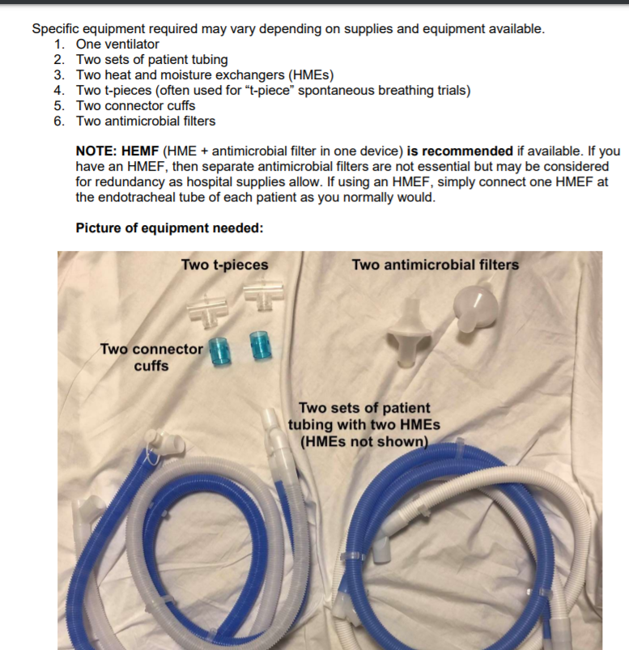

* <https://emcrit.org/pulmcrit/split-ventilators/> - at the bottom has a good video on splitting ventilators and considerations to make
* <https://www.medrxiv.org/content/10.1101/2020.04.03.20052217v1.full.pdf> - These people p much did what we’re trying to do :-)

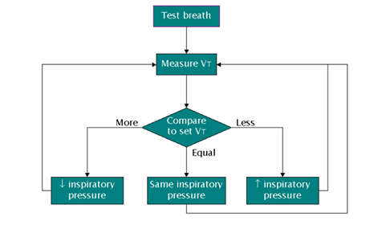

* Arduino Spirometer: [https://www.instructables.com/id/Spirometer/](https://l.messenger.com/l.php?u=https%3A%2F%2Fwww.instructables.com%2Fid%2FSpirometer%2F&h=AT1GN0QOi9lfU6fcoyJvcAByLBn-1MjRY7nZXVai1lTXBWtIU7zPJKK8ZAmWCziPTazN-yM6XsHUDJT3oQJKB9XxeKlepIk6rMyUTElRabob0DeeCA8zQgQ8jJJJeudHlVVOPp4D014XatM8eVhyWQ)

**Materials Needed**

* [CO2 sensor](https://www.adafruit.com/product/3709)
* Buzzer (for alarm)
* Rubber tubing
* HEPA-Filter
* One-way valve